One hot encoding is used when we have nominal(Having no order data) data.

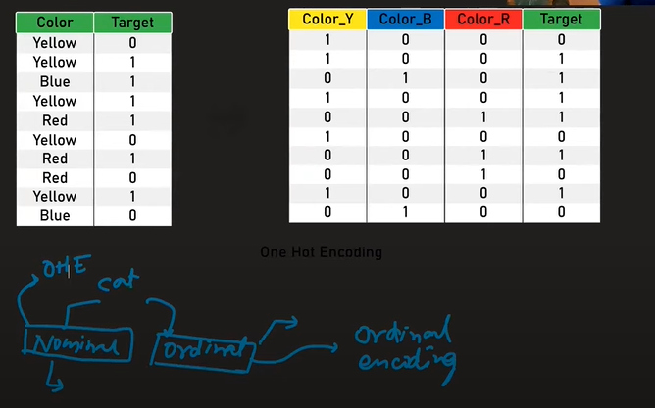

What is Multicollinearity?

Dummy Variable trap

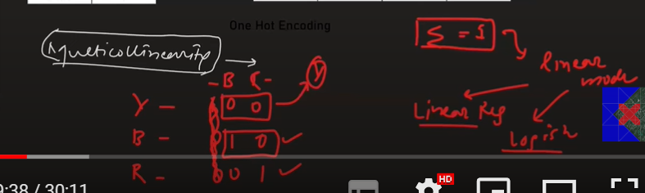

Note: Actually, we can demonstrate n cols to (n-1) cols to avoid dummy variable trap.

